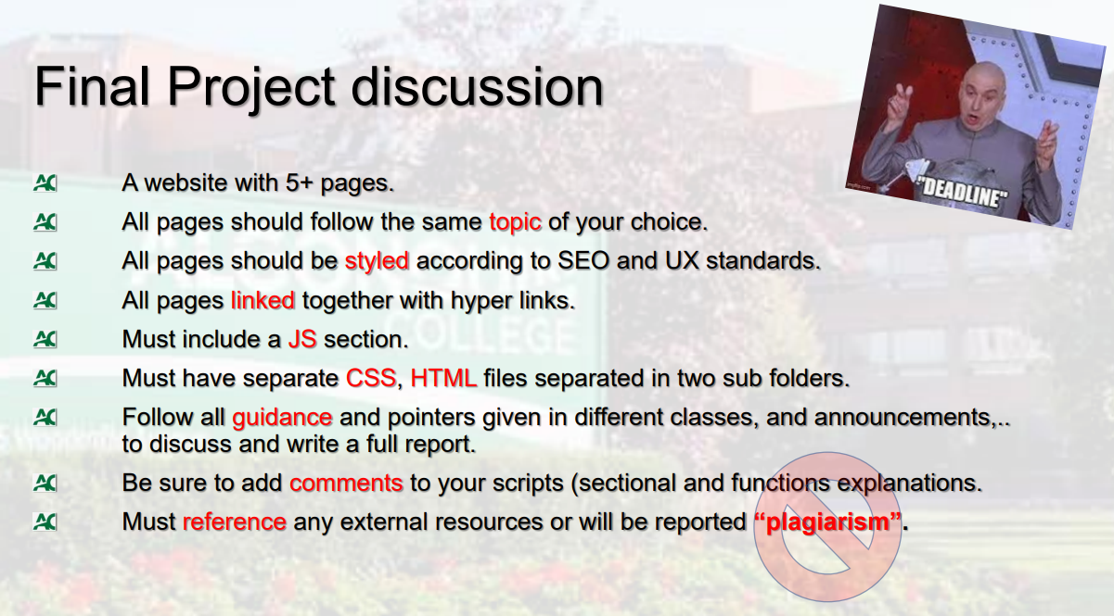

**RESOURCES**

* **IMAGES**

[Cooking Logos PNG - Bing images](https://www.bing.com/images/search?view=detailV2&ccid=UvL064kf&id=C3D1A0CD5665C842D828F9AD9A2E007D262F9DC6&thid=OIP.UvL064kfswcJy0ABEVRC8AAAAA&mediaurl=https%3a%2f%2fpngimage.net%2fwp-content%2fuploads%2f2018%2f05%2fcooking-logo-png-5.png&cdnurl=https%3a%2f%2fth.bing.com%2fth%2fid%2fR.52f2f4eb891fb30709cb4001115442f0%3frik%3dxp0vJn0ALpqt%252bQ%26pid%3dImgRaw%26r%3d0&exph=397&expw=289&q=Cooking+Logos+PNG&simid=608009022724790673&FORM=IRPRST&ck=C94FD180AAC695C945A8D27E3472E09F&selectedIndex=0&idpp=overlayview&ajaxhist=0&ajaxserp=0)

[Blue Home Button - Bing](https://www.bing.com/images/search?view=detailV2&ccid=JXim8kre&id=F68CDAC8BEC483932790CCE89AA0586499DF9255&thid=OIP.JXim8kredbrdL0Fm4sAD9wHaHw&mediaurl=https%3a%2f%2fwww.clipartmax.com%2fpng%2fmiddle%2f217-2174484_blue-home-button-png-www-pixshark-com-images-galleries-linked-in-logo.png&cdnurl=https%3a%2f%2fth.bing.com%2fth%2fid%2fR.2578a6f24ade75badd2f4166e2c003f7%3frik%3dVZLfmWRYoJrozA%26pid%3dImgRaw%26r%3d0&exph=880&expw=840&q=Blue+Home+Button&simid=608022981378329330&FORM=IRPRST&ck=E91A1A3C3C406DF9B3796A5C39BA7CA1&selectedIndex=0&ajaxhist=0&ajaxserp=0)

[instagram png - Bing images](https://www.bing.com/images/search?view=detailV2&ccid=A%2fQLZ7Y9&id=6F7CFCA6BEF0B34D833611BDB10E52BBAA60A613&thid=OIP.A_QLZ7Y9nBwaWnkhCbvGmQHaHZ&mediaurl=https%3a%2f%2fpngimg.com%2fuploads%2finstagram%2finstagram_PNG10.png&cdnurl=https%3a%2f%2fth.bing.com%2fth%2fid%2fR.03f40b67b63d9c1c1a5a792109bbc699%3frik%3dE6ZgqrtSDrG9EQ%26pid%3dImgRaw%26r%3d0&exph=1454&expw=1455&q=instagram+png&simid=608049313830289688&FORM=IRPRST&ck=199A07D677841BE3CC84CF0E10BE7497&selectedIndex=0&ajaxhist=0&ajaxserp=0)

[pinterest png - Bing images](https://www.bing.com/images/search?view=detailV2&ccid=3N9rWN%2F9&id=144E487213FC94C8003BB51CD7C959812DBD5212&thid=OIP.3N9rWN_9Jhx7JDVDkXZ5IAHaHa&mediaurl=https%3A%2F%2Fth.bing.com%2Fth%2Fid%2FR.dcdf6b58dffd261c7b24354391767920%3Frik%3DElK9LYFZydcctQ%26riu%3Dhttp%253a%252f%252fwww.pngall.com%252fwp-content%252fuploads%252f2016%252f07%252fPinterest-PNG-Clipart.png%26ehk%3DMEiKbAGMBfln60e8dmCosyScUG1pvoFWw9ufxYy8ORU%253d%26risl%3D%26pid%3DImgRaw%26r%3D0&exph=512&expw=512&q=pinterest+png&simid=608032584917665622&form=IRPRST&ck=A1A6C6F8926862FC50157F9FF24E4D94&selectedindex=17&ajaxhist=0&ajaxserp=0&vt=0&sim=11)

[Facebook Symbol - Bing images](https://www.bing.com/images/search?view=detailV2&ccid=OaHWiuwB&id=947BB7AA25EA81B7A6404229F49913970EE904A1&thid=OIP.OaHWiuwB46nOfArXuanGsgHaGp&mediaurl=https%3A%2F%2Fth.bing.com%2Fth%2Fid%2FR.39a1d68aec01e3a9ce7c0ad7b9a9c6b2%3Frik%3DoQTpDpcTmfQpQg%26riu%3Dhttp%253a%252f%252fpluspng.com%252fimg-png%252ffacebook-logo-png-image-2335-1403.png%26ehk%3DA6gzMacsllFktQ3DwgKCwXCKBhdJNlpCydh%252bXl3VABQ%253d%26risl%3D%26pid%3DImgRaw%26r%3D0&exph=1258&expw=1403&q=Facebook+Symbol&simid=607998658984492993&form=IRPRST&ck=FFB804E242A92FD36B98606B3B5A0C7B&selectedindex=6&ajaxhist=0&ajaxserp=0&vt=0&sim=11)

[Search Png Icon - Bing images](https://www.bing.com/images/search?view=detailV2&ccid=%2fgWKb7Xo&id=52EC7296260EBE2457877AA4F04259023B07B865&thid=OIP._gWKb7XothF92LD2Fq5NLwHaHM&mediaurl=https%3a%2f%2fcdn.onlinewebfonts.com%2fsvg%2fimg_391459.png&cdnurl=https%3a%2f%2fth.bing.com%2fth%2fid%2fR.fe058a6fb5e8b6117dd8b0f616ae4d2f%3frik%3dZbgHOwJZQvCkeg%26pid%3dImgRaw%26r%3d0&exph=954&expw=981&q=Search+Png+Icon&simid=608034410298417375&FORM=IRPRST&ck=31C116E1C046FE98AB1D31DED02E92FF&selectedIndex=0&idpp=overlayview&ajaxhist=0&ajaxserp=0)

[swilling knives logo png - Bing images](https://www.bing.com/images/search?view=detailV2&ccid=XE6ya8HG&id=2913C3B3EB1E83E4472310831AD2682D3E53EDE1&thid=OIP.XE6ya8HGqNXy8bMjmoDnzQHaJo&mediaurl=https%3a%2f%2fth.bing.com%2fth%2fid%2fR.5c4eb26bc1c6a8d5f2f1b3239a80e7cd%3frik%3d4e1TPi1o0hqDEA%26riu%3dhttp%253a%252f%252flogos-download.com%252fwp-content%252fuploads%252f2016%252f10%252fZwilling_logo.png%26ehk%3dgvPi2h1Ye3qb3tjRq33RrNzzx29%252bvxe25%252f3jwbrFwVk%253d%26risl%3d%26pid%3dImgRaw%26r%3d0&exph=6000&expw=4614&q=swilling+knives+logo+png&simid=607992873680266859&FORM=IRPRST&ck=C364B8473AF62D7D03681B66138D45BA&selectedIndex=1&ajaxhist=0&ajaxserp=0)

[le creuset logo png - Bing images](https://www.bing.com/images/search?view=detailV2&ccid=KhKajBfB&id=445BBE27B771BE56CB913EB8FAEE1389DB92A394&thid=OIP.KhKajBfBM4SkNWqkcEyhQwAAAA&mediaurl=https%3A%2F%2Fth.bing.com%2Fth%2Fid%2FR.2a129a8c17c13384a4356aa4704ca143%3Frik%3DlKOS24kT7vq4Pg%26riu%3Dhttp%253a%252f%252fwww.legacy-village.com%252fwp-content%252fuploads%252f2015%252f03%252fLeCreuset_Logo1.png%26ehk%3Dohiw9uedz8h1%252f293XMWD9%252bPP5zfH4%252fzcGSTS2Y5JGak%253d%26risl%3D%26pid%3DImgRaw%26r%3D0&exph=454&expw=454&q=le+creuset+logo+png&simid=608044318783115998&form=IRPRST&ck=6E517F729DC8BFE8377163B668236627&selectedindex=1&ajaxhist=0&ajaxserp=0&vt=0&sim=11)

[Lodge Cast Iron PNG - Bing](https://www.bing.com/images/search?view=detailV2&ccid=eEHaO4gV&id=AC753787D7CC2BD8CB4A32F90602A88C56067FFC&thid=OIP.eEHaO4gVpPx_XxsdJx4fQQHaDO&mediaurl=https%3a%2f%2fwinkelman.com%2fwp-content%2fuploads%2f2017%2f11%2fLodge-Cast-Iron-logo.png&cdnurl=https%3a%2f%2fth.bing.com%2fth%2fid%2fR.7841da3b8815a4fc7f5f1b1d271e1f41%3frik%3d%252fH8GVoyoAgb5Mg%26pid%3dImgRaw%26r%3d0&exph=283&expw=650&q=Lodge+Cast+Iron+PNG&simid=608032735269834574&FORM=IRPRST&ck=D6A83A751072166A0B875448753123E9&selectedIndex=0&idpp=overlayview&ajaxhist=0&ajaxserp=0)

[KitchenAid Logo PNG - Bing images](https://www.bing.com/images/search?view=detailV2&ccid=5QF1iyc8&id=86BBC946969B84AC16840F60B5B13281B2B0B813&thid=OIP.5QF1iyc8Ue24cBbeWxUqzQHaD6&mediaurl=https%3a%2f%2fwww.pfister.ch%2fmedias%2fsys_master%2froot%2fhbe%2fh43%2f8932498800670%2fkitchenaid-logo-website.png&cdnurl=https%3a%2f%2fth.bing.com%2fth%2fid%2fR.e501758b273c51edb87016de5b152acd%3frik%3dE7iwsoEysbVgDw%26pid%3dImgRaw%26r%3d0&exph=340&expw=644&q=KitchenAid+Logo+PNG&simid=608036398859691622&FORM=IRPRST&ck=23DEFED2BF038159B31EF321F560F2FC&selectedIndex=0&idpp=overlayview&ajaxhist=0&ajaxserp=0)

[kuhnrikon logo png - Bing images](https://www.bing.com/images/search?view=detailV2&ccid=B8dxrU8a&id=5E486E260CABFADD926B929203035E401DC2FE80&thid=OIP.B8dxrU8aAseKn3w80XpqcQAAAA&mediaurl=https%3a%2f%2fglopstudio.fr%2fwp-content%2fuploads%2felementor%2fthumbs%2fKuhnRikon_Logo-ov2k3tq5dv2z6r9qip0difuudc5h8ise3gh4zd3cf4.png&cdnurl=https%3a%2f%2fth.bing.com%2fth%2fid%2fR.07c771ad4f1a02c78a9f7c3cd17a6a71%3frik%3dgP7CHUBeAwOSkg%26pid%3dImgRaw%26r%3d0&exph=80&expw=110&q=kuhnrikon+logo+png&simid=608053398341223811&FORM=IRPRST&ck=82D56FF549F1CC0908DA486AB2F6C846&selectedIndex=3&ajaxhist=0&ajaxserp=0)